HTML5 Native Features

Version: 1.0

Document Control

Reference No: | IRL-Enterprise Mobility Tech Labs/HTML5 Native Features
Security Classification: | Confidential
Issue Date: | 28/01/2011
Author (s): | Name |  | Title
Author (s): | Vivek Srivastav |  | Senior Software Engineer
Reviewer (s): | Name |  | Title
Distribution: | Name |  | Location
Document History: | Date | Revision | Change
Document History: | 31/01/2011 | 1.0

HTML 5 NATIVE FEATURE

In HTML5 we can access native features of a mobile device like:

- Geolocation
- File System
- Call
- SMS
- Contact List (W3C Draft under Working)
- Camera (W3C Draft under Working)

Geolocation
In Geolocation we can access the co-ordinates of an end user (Longitude and Latitude) and the basis of co-ordinates we can show user location on Google map because in html5 Geolocation API we have functionality through which we can directly show user location on Google map.

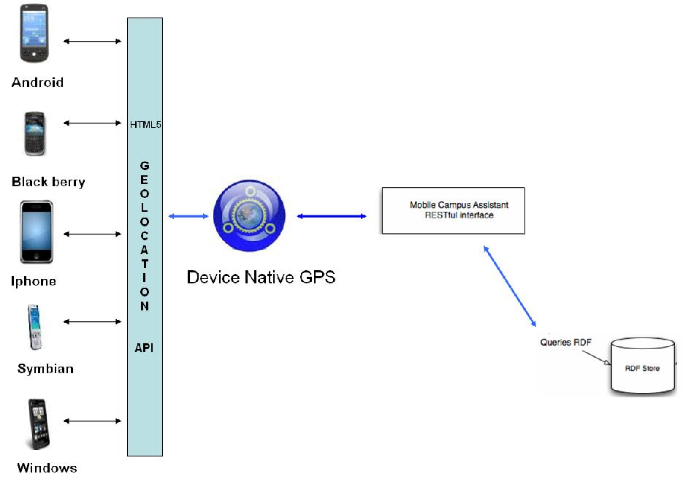

Geolocation API Architecture
In the above diagram we have different mobile devices which directly access geo-
Location API of html5 and with the help of geo API devices can directly communicate with native device GPS hardware. In Geolocation architecture we have a RDF store which is responsible for providing exact location on the basis of longitude and latitude.
(The Resource Description Framework (RDF) is a family of World Wide Web Consortium (W3C) specifications originally designed as a metadata data model. It has come to be used as a general method for conceptual description or modeling of information that is implemented in web resources, using a variety of syntax formats.)

HTML5 syntax for getting location through Geolocation API:

navigator.geolocation.getCurrentPosition (success, error)

If the device supports the gps then it’s call directly success and if the device fails to find internal gps then its call to error.

For Success:
function success(position) {
var s = document.querySelector('#status');

if (s.className == 'success') {
// not sure why we're hitting this twice in FF, I think it's to do with a cached result coming back
return;
}

For Error:
function error(msg) {
var s = document.querySelector('#status');
s.innerHTML = typeof msg == 'string' ? msg : "failed";
s.className = 'fail';

// console.log(arguments);
}

File System
In html5 file system api we can directly access the internal file system of a device like memory card or phone memory and we can directly select any file from file system and upload to html5 page.

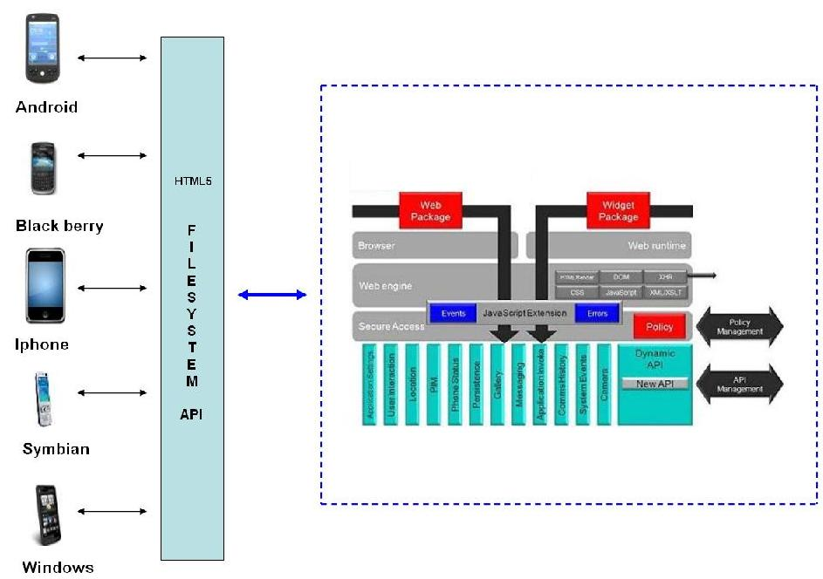

File System Architecture
In the above diagram we have different devices which are directly access file system api of HTML5 and with the help of these api’s a user can directly access the file system of devices like galley and phone memory etc.
In Native part we have different layer on a device on top we have Web packages which bypass through java script extension and then access the gallery below policy management.

HTML5 syntax for using file-system api:

First we have to provide an input type in html tag like this-

<input type="file" accept="image/*;capture=filesystem" id="capture">

Where accept shows the file format acceptance extension if we use image then it means that we can access the image directly from the device file system.
We can also use image/*, sound/*, or video/* mime types in accept attribute user agent can invoke a file picker that allows respectively the user to take a picture, record a sound file, or record a video in addition to selecting an existing file from the file system. Similarly The capture parameter can take one of the following values: camera, camcorder, microphone, filesystem. These values indicate which source the file picker interface should preferably present to the user by default. But we all know that HTML5 is very new and its api’s are also in under development, That’s why we can’t commit its behavior on each and every device, According to me I Am tested this API’s on Blackberry 6.0, android 2.2 and Iphone 3.

So for complete behavior please look on below table:

Device | Attribute (accept) | Remark | Attribute (capture) | Remark
Blackberry OS 6.0 | image/* | Working | Camera | Working
 | sound/* | Working | Camcoder | Not Working
 | Video/* | Working | microphone | Not Working
 |  |  | filesystem | Working
Android 2.2 | image/* | Working | Camera | Not working
 | sound/* | Working | Camcoder | Not Working
 | Video/* | Not Working | microphone | Working
 |  |  | filesystem | Working
Iphone 3 | image/* | Working | Camera | Not Working
 | sound/* | Working | Camcoder | Not Working
 | Video/* | Not Working | microphone | Not Working
 |  |  | filesystem | Working

Call
In html5 we can call from html5 web page to any number using device internal calling
Feature this feature is same like xhtml because we can also use calling feature using
Xhtml.

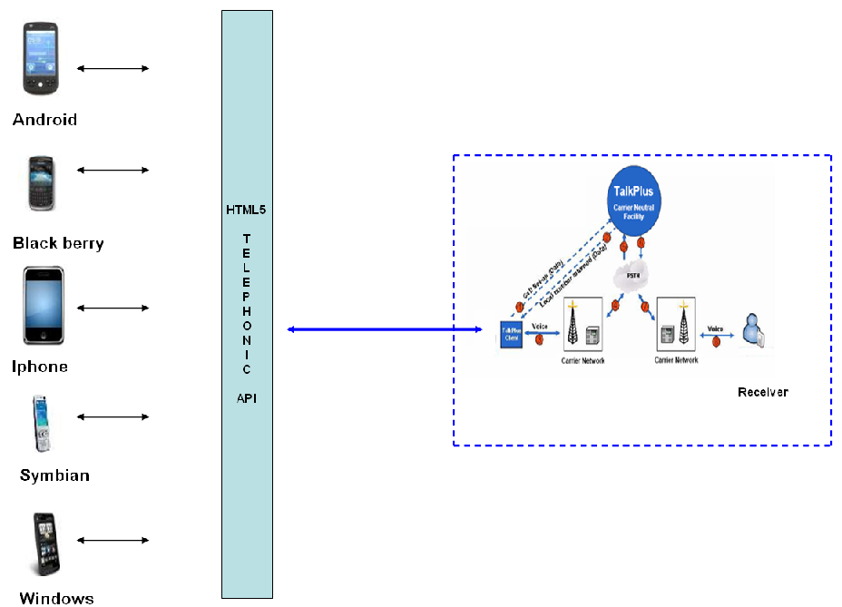

Call API Architecture
In the above diagram we have different devices which are directly access the html5
Telephonic api and with the help of telephonic api we can directly get calling control of
Device and call to any number.

HTML5 syntax for using call api:

<a href="tel:+918600993494" data-role="button" rel=external>Call Now</a>

We have to pass only contact number in href attribute.

SMS
In html5 we can sms from html5 web page to any number using device internal sms
Feature this feature is same like xhtml because we can also use sms feature using
Xhtml.

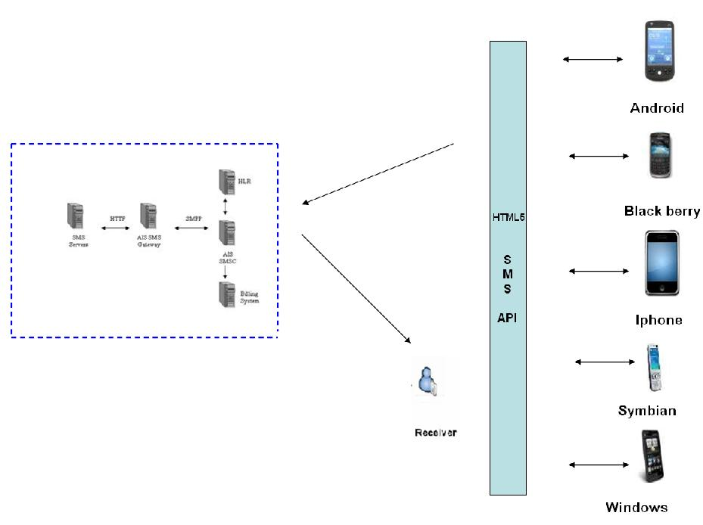

SMS API Architecture
In the above diagram we have different devices which are directly access the html5
Sms API and with the help of sms API we can directly get sms window control of
Device and sms to any number.

HTML5 syntax for using sms api:

<a href="sms:+918600993494">Send information to me</a>

We have to pass only contact number in href attribute.

